**1.0 Subsystem Overview:**

The design is located in the receiving portion of the radio; its purpose is to ensure the input signals from the antenna are ready to be decoded by the demodulator. The design comprises of the following subcomponents:

* A bandpass filter to filter incoming radio frequency signals.
* A voltage limiter to prevent damage to the mixer and other sensitive components in the receiver.
* A quadrature mixer to downconvert the radio frequency signal to the baseband frequency.
* A lowpass filter and amplifier which remove the higher frequency band of the mixer product and provide sufficient gain for the signal to be usable by the demodulator.

**2.0 Input/Output Signals:**

| Signal Name | Input/Output | Description |
| --- | --- | --- |
| RX_SIG  (Radio frequency signal) | Input | Signal picked up by the antenna. |
| /TXEN  (Transmit enable signal) | Input | 3.3V enable signal sent to the receiving and the transmitting chains of the radio to indicate the mode of the radio. When high (3.3V) the radio is in receiving mode and when low (0V) the radio is in transmit mode. |
| In Phase LO Signal | input | 3.3V unipolar signal that is generated by the Local Oscillator. This signal has a phase shift of 0 degrees. |
| Quadrature LO Signal | Input | This is the second signal generated by the Local Oscillator and it is identical to the one above except it is quadrature; meaning it is 90 degrees out of phase with the signal above. |
| I Signal | Output | This signal is generated by the mixer and in phase LO signal, followed by a low pass filter and an amplifier. This signal has a 0-degree phase shift. |
| Q Signal | Output | This signal is generated by a second mixer having the quadrature LO signal as input, followed by a low pass filter and an amplifier. This signal has a phase shift of 90 degrees. |

**3.0 Subsystem Design:**

The bandpass filter receives the RX_SIG (signal from the antenna) via pin 1 of J1 (Appendix A). RX_SIG then passes through a 3rd-order Butterworth LC ladder filter (Appendix B). The calculations for the order of the filter and the component values are included in Appendix C. As can be seen in the bode plot of the filter (Appendix D) the filter has a maximally flat 3db passband from ~8-16MHz. After the signal has been filtered it passes through a voltage limiter circuit implemented using two anti-parallel Schottky diodes D1 and D2 (depicted in Appendix E); which have been simulated to ensure their switching speed and voltage drop work as expected to limit the output to ±0.7Vp. The simulations for the voltage limiter are included in Appendix F.

The signal (RF) is then passed to the two in-phase (I) and quadrature (Q) mixers’ RF input ports and the signals (LO_F1_0 and LO_F1_90) are inputted into the LO ports of the mixers (Appendix A). The mixer adopts the Gilbert Cell architecture, an accurate topology which is commonly used in industry[1]. Appendix I shows the RF and LO signals first go through a transformer (T1 & T2) to create differential signals, used to drive the differential pairs of N-channel MOSFETs (Q1-6). The model for these transistors was carefully compared to others as depicted in Appendix K. With a gate to source capacitance of 83 pF and an input resistance of 50 ohms gives a time constant of 4.15 ns which is sufficiently small for an RF signal with a maximum frequency of 16 MHz. Pull-up resistors (R9 & R10) were utilized to conduct current into the IF ports when any of the input signals were either high or low. The simulation results in Appendix L illustrate the successful mixing of the two input signals with the larger frequency component centred at 10KHz, meeting the ICD requirements (Appendix J). Due to potential failures of the Gilbert Cell, a fail-safe mixer IC was placed in parallel using simple 2-pin connectors (J1-4).

The I and Q signals produced by the mixers are processed via two second-order Butterworth Sallen-Key Low Pass Filters (LPF), chosen for their simplicity and flat passband. Operational amplifier U1, central to the LPF, ensures effective high-frequency attenuation, as shown in the simulation in Appendix H. This filter, coupled with the IQ amplifier, attains a 30 dB gain, 96 kHz cutoff frequency and adheres to the 0-5V output voltage specification required for Subsystem B, detailed in the figure in Appendix G. The calculations for the components are shown in Appendix M.

**Citations:**

1. S. Mehta, X. J. Li, and M. Donelli, “Recent advancement in the design of Mixers for software‐defined radios,” *International Journal of RF and Microwave Computer-Aided Engineering*, vol. 32, no. 2, Nov. 2021. doi:10.1002/mmce.22963

**Appendix:**

Appendix A:

Schematics of the connectors and the hierarchical overview of the design. The TPS22810DBVR is just a power switch that gets enabled when /TXEN is high.

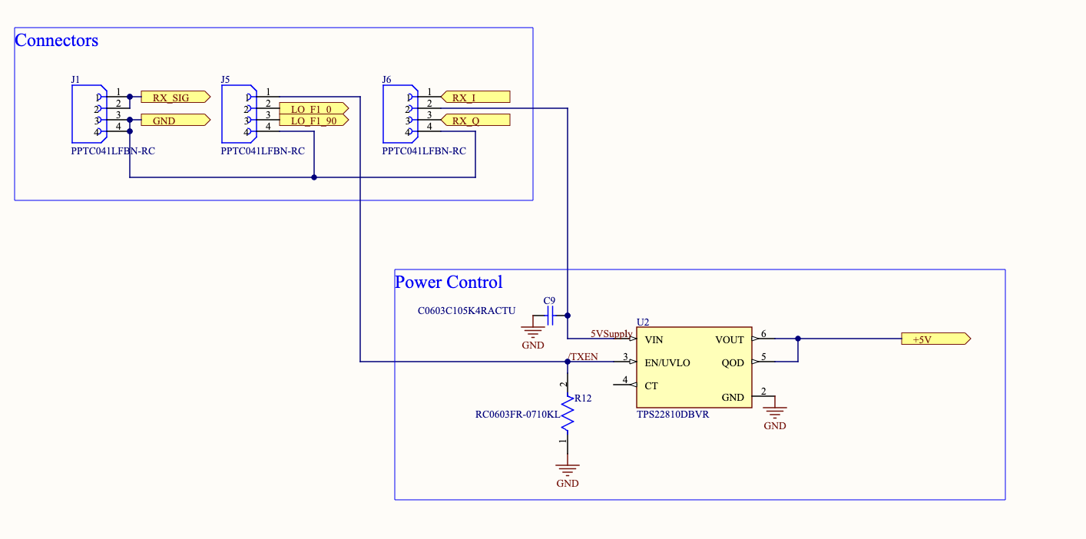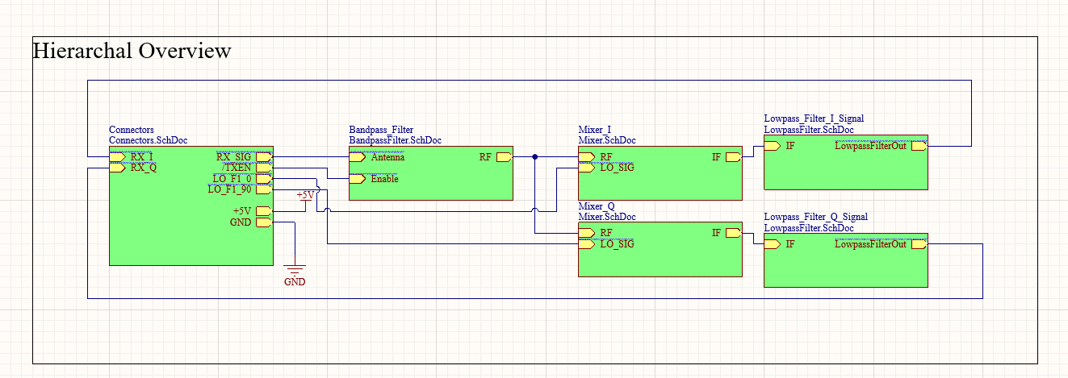

Appendix B:

Schematic of the band-pass filter.

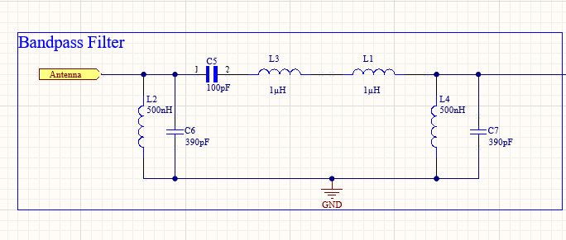

Appendix C:

Calculations for the filter order and inductance and capacitance value of 3rd order Butterworth band pass filter. Note that the filter has a lower stop frequency of 3MHz to ensure noisy AM (can reach 1.6MHz) signals are filtered out.

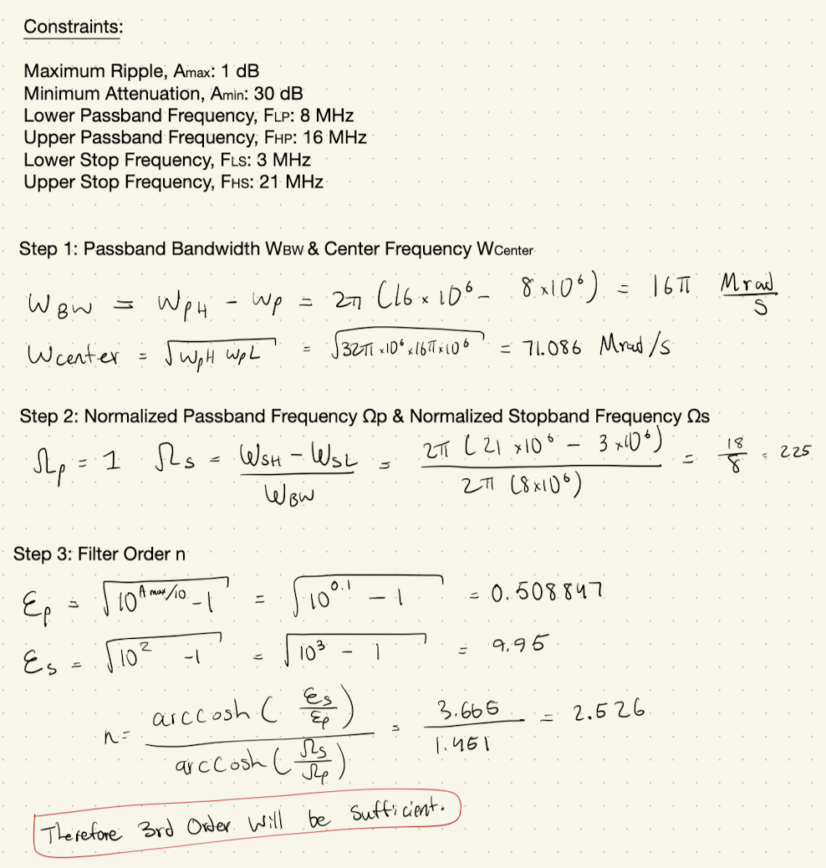

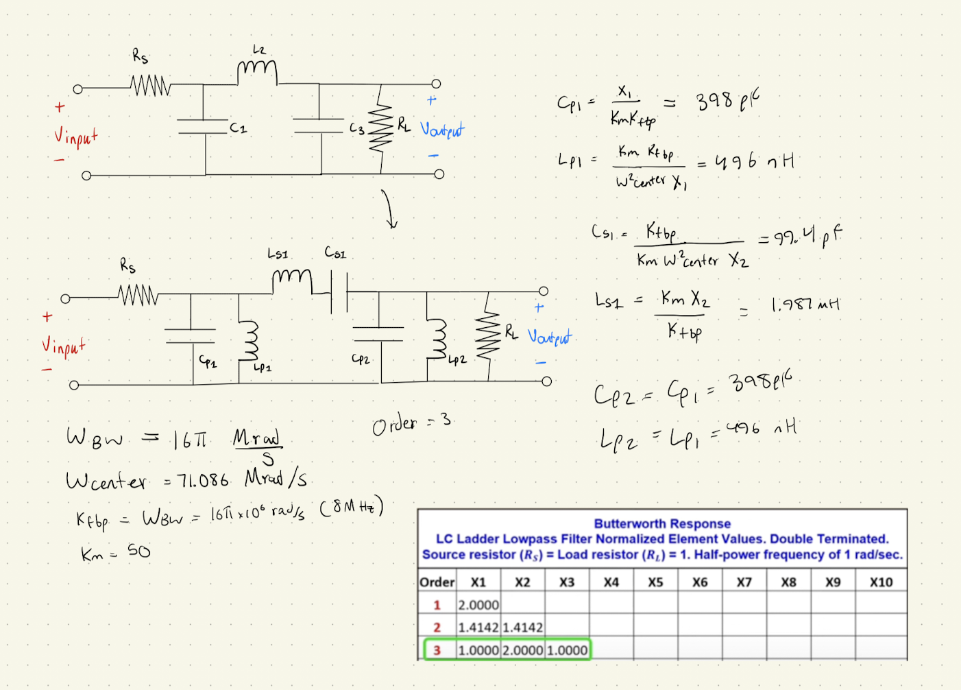

Appendix D:

Bode plot of the bandpass filter.

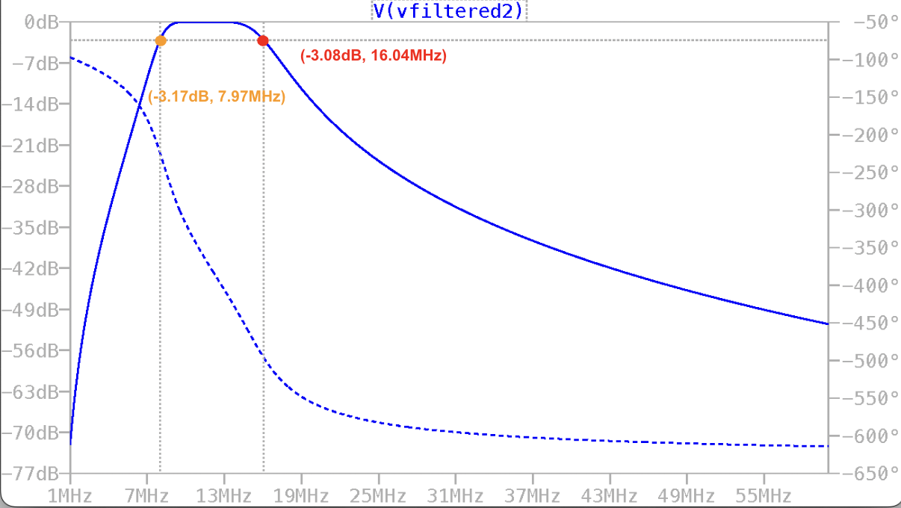

Appendix E:

Schematic of the voltage limiter circuit.

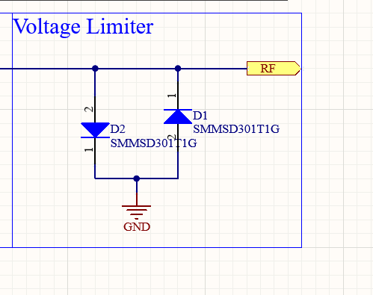

Appendix F:

The simulations for the output of the voltage limiter circuit shown below. Green plot is input of 3 Vp and the red is the output of the limiter.

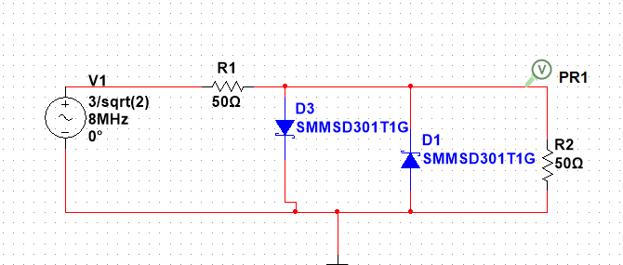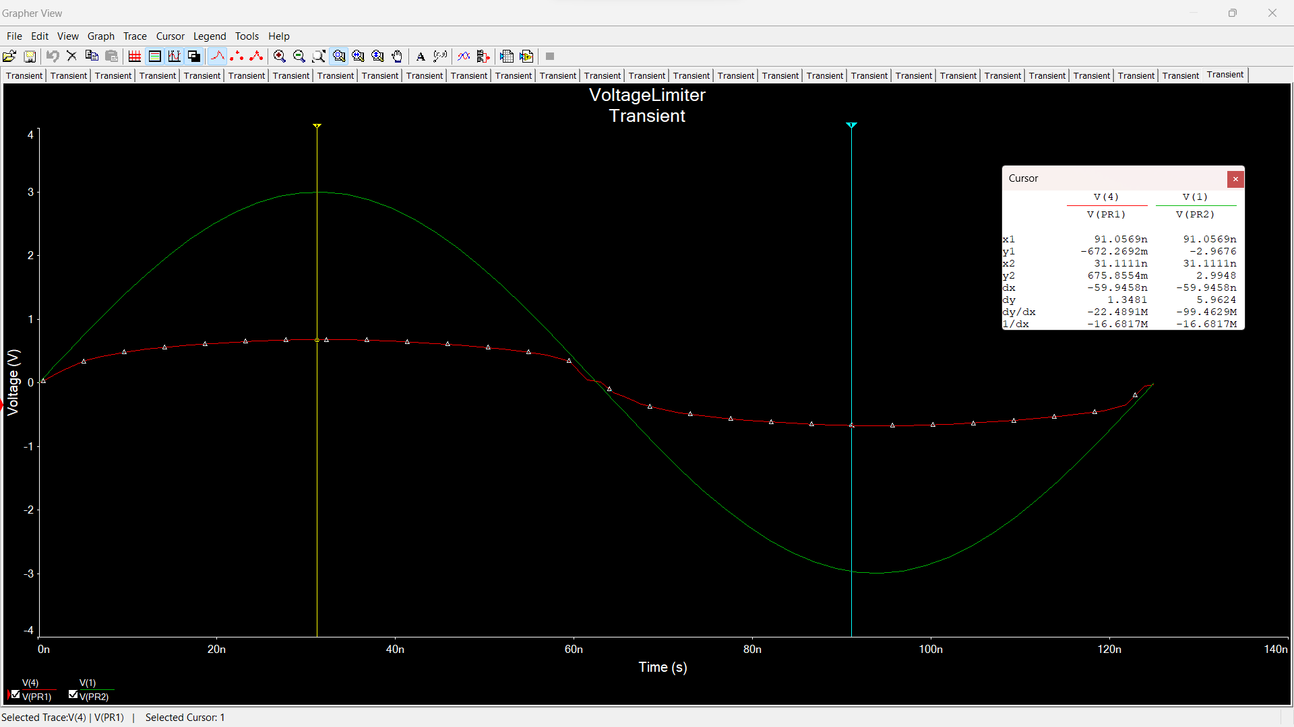

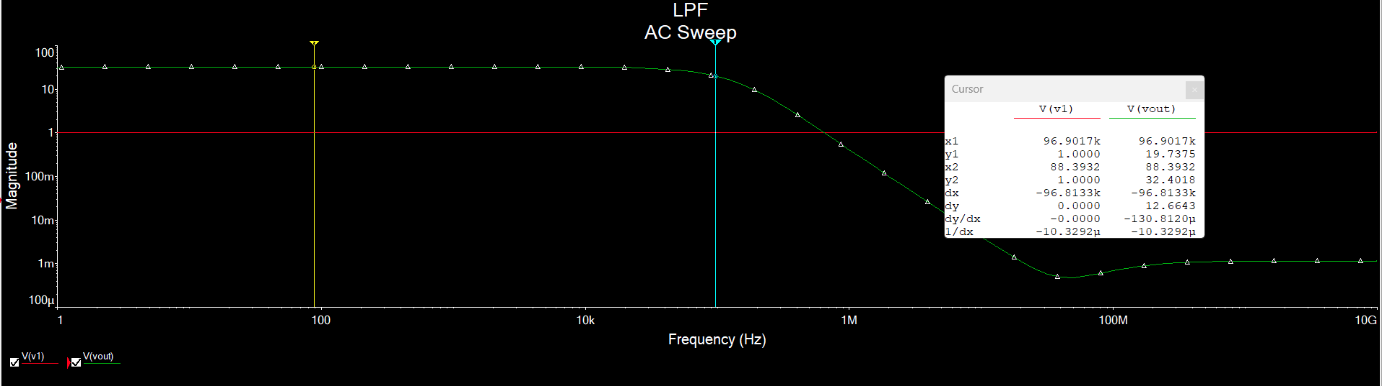

Appendix G:

Schematic of the low-pass filter and the amplifier.   
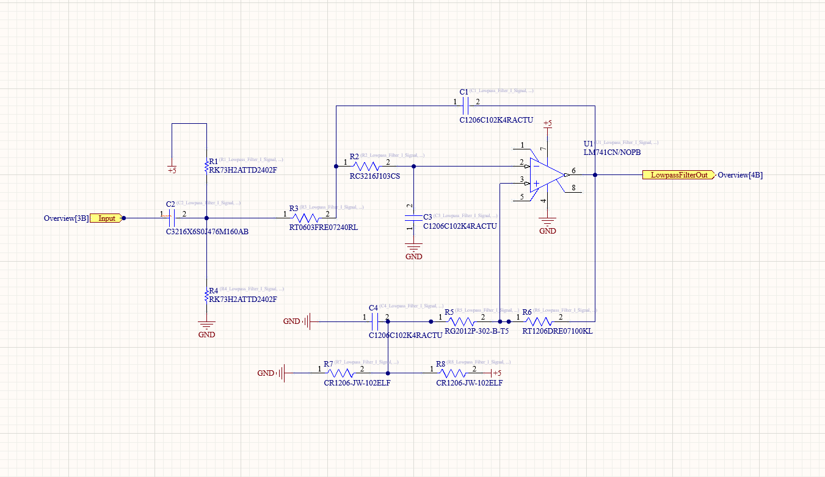

Appendix H:

The figures below is the simulations over the low pass filter and amplifier

Simulation over Transient response of 10 kHz input signal(Red signal is the input, and the green signal is the output)

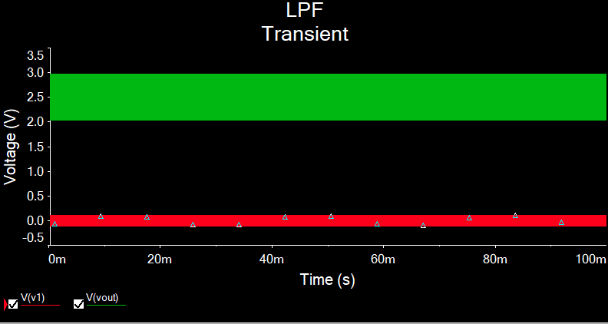

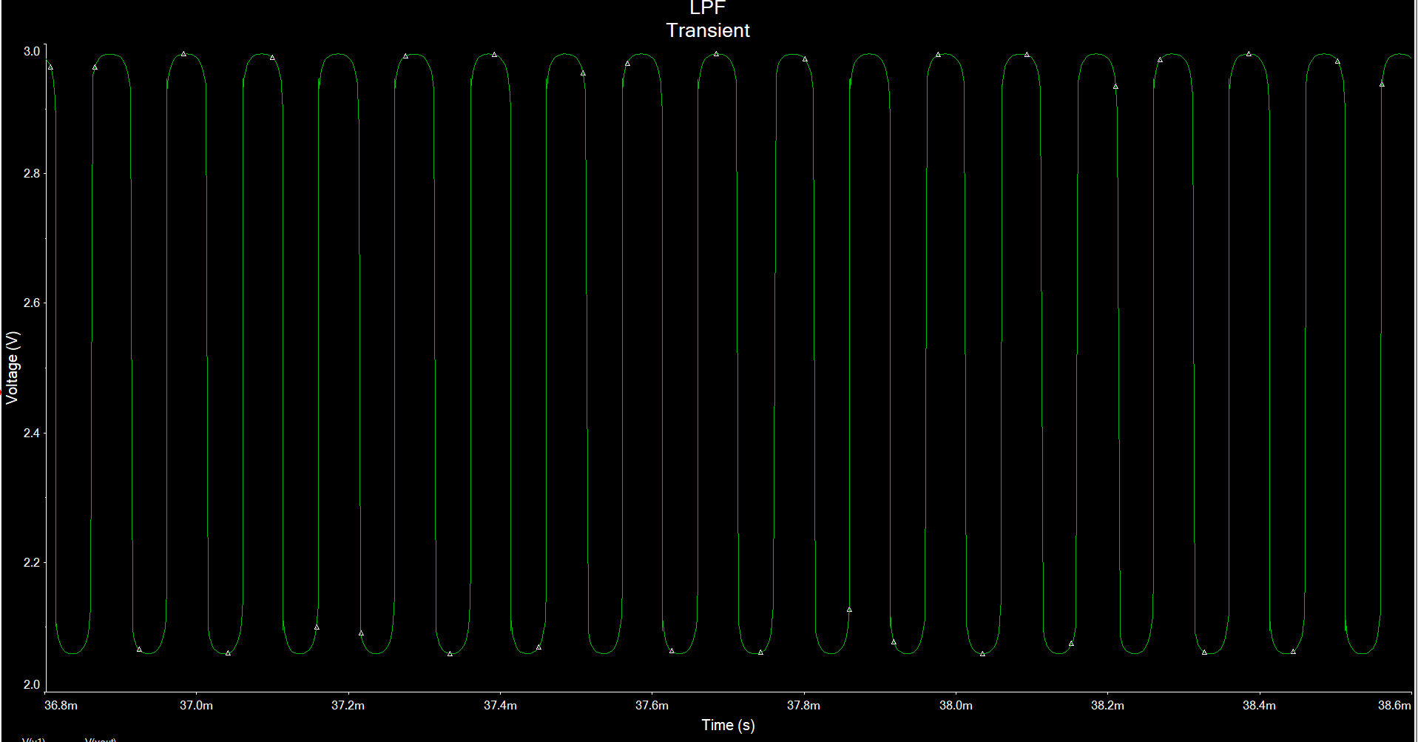

Simulation over Transient response of 200 kHz input signal(Red signal is the input, and the green signal is the output)

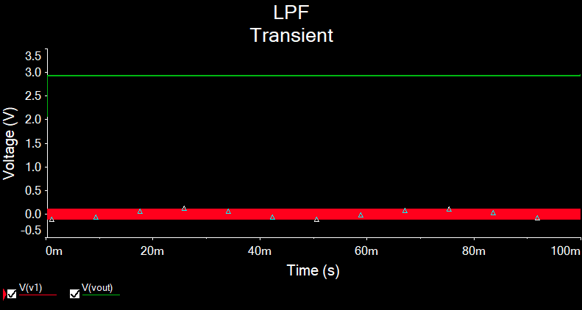

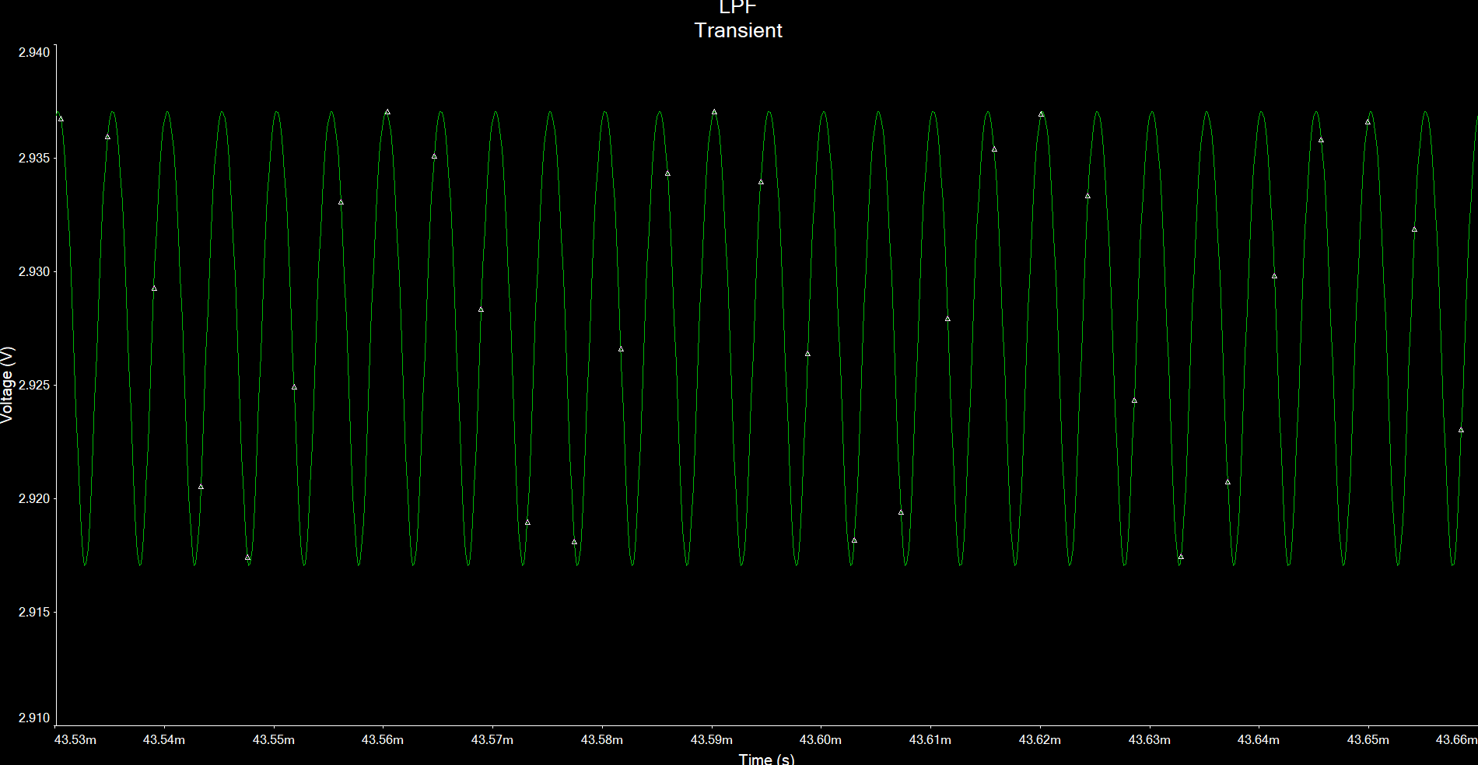

Appendix I:

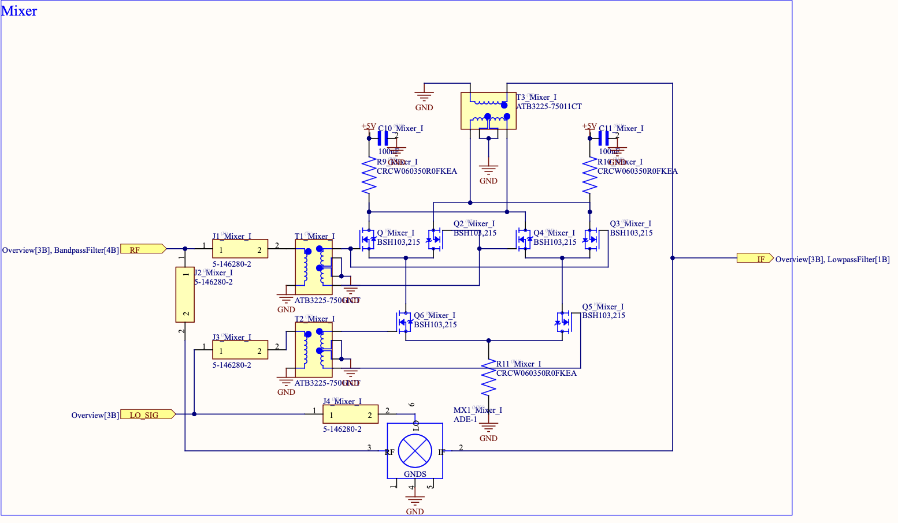

Appendix J:

| Centre frequency at 10KHz [IV] | Frequency of outputs in KHz | 10KHz | The down-converted frequency should be centred around 10KHz as the demodulator is designed to work with this frequency. |
| --- | --- | --- | --- |
| The two output signals should be 90 degrees out of phase [V] | Phase difference of outputs in degrees | 90 ± 12.5° | The I and Q signals should have a 90-phase difference which cannot deviate more than 12.5 degrees to prevent errors in the demodulation process. |
| Amplitude of the outputs are balanced within 1dB [VI] | Difference in gain of the outputs in dB | < 1dB | The difference between the gain of the I and Q signals should not be greater than 1dB to ensure the accuracy of outputs. |

Appendix K:

Component comparison table:

| Component | Part number | justification |
| --- | --- | --- |
| NMOS | BSH103,235 | Chosen due to a good balance between price, low internal resistance 0.4ohms which is negligible compared to 50 ohms we are using for pull up and down resistors. Gate to source capacitance is also small, 83pF. And the threshold voltage is 0.4 V which is the lowest on the market. |
| NMOS | IQDH29NE2LM5ATMA1 | Considered due to a low internal resistance of 0.29 mOhm. Not chosen since it is too expensive, 5.47$. |
| BJT | NJVMJK32CTWG | Considered due to its ability to conduct with current and lower input impedance, but not chosen due to its slower switching speed and temperature dependence. |
| NMOS | 2SK122800L | Considered due to a very low gate to source capacitance of 2.9pF but there are none in stock. |

Appendix L:

Simulation results of the mixer:

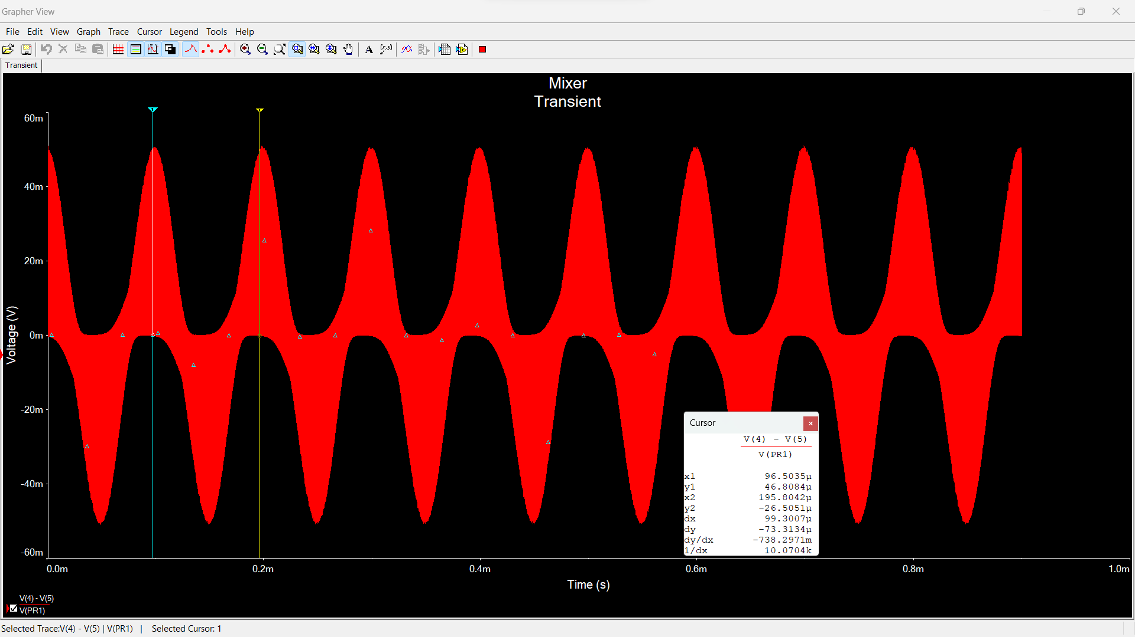

The schematic that was tested is given below. A weak RF signal was replicated with 0.1 vpp to see if the mixer still conducts current into the IF ports if the RF signal is really weak, and the results show that it does.

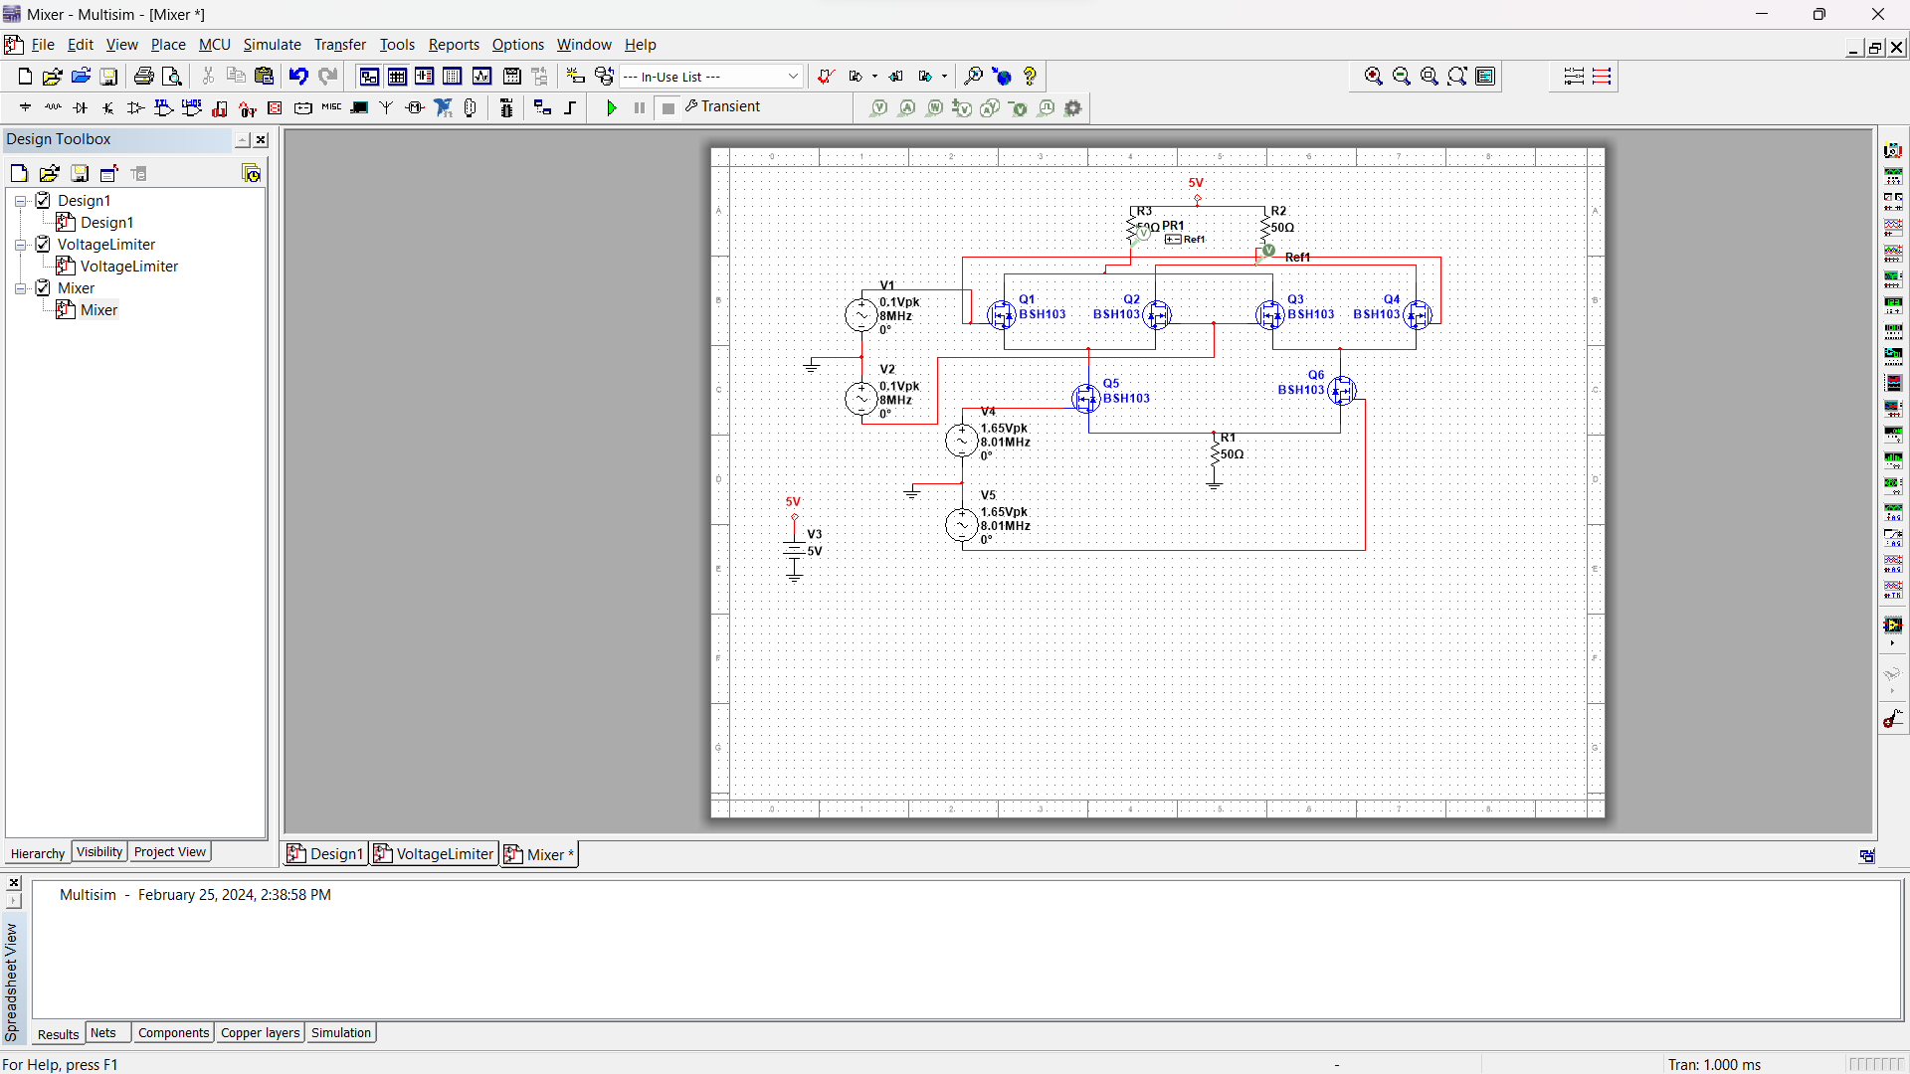

**Appendix M:**

Calculations for the LPF and amplifier component values:

